Power and Thermal Test Report

This report presents the results of power and thermal measurements for various stress test activities on the device. Each entry includes measured current draw, power draw from the PWR meter, observed heat levels, and Vivado's power estimation (static, dynamic, and total).

Data Overview
The table below outlines the key columns in the dataset:
- Activity: Description of the stress test performed.
- State: Indicates whether the device was idle/programmed/active during the test.
- Current draw #V [A]: Measured current at a given voltage level.
- Power draw PWR meter [W]: Measured power consumption using a FNB58 PWR meter.
- Heat: Qualitative observation of heat production (e.g., 'significant', 'burning'). Some of the tests were also measured with a Flir One Edge thermal imaging camera.
- Vivado PWR – Static/Dynamic/Total [W]: Power estimates reported by Vivado, broken down into static and dynamic components.
- In this document W_INA and W_MTR will be used to signify the measurement results from the INA sensors and the power meter respectively.

Results and Analysis

- Activity: Idle and not programmed
- We also measured the static power consumption of the board when the FPGA has minimal or no configuration data.
- The utilization was extremely low, under 0.5%
Conclusions:
- Naturally, the lowest values were measured when the FPGA is uninitialized (no configuration data uploaded), 0.48 W_INA and 1.76 W_MTR. The results are greater than zero due to the other active components present on the board, which are talked about in a following chapter.
- If the FPGA is initialized however, even with a program that has no utilization and accomplishes nothing (AICORS_blank), the power consumption goes up by 0.1W. As the Vivado power estimation is 0.26W, my guess is that the unaccounted 0.16W is part of the base power consumption by the FPGA when it is powered on.
- My theory is that the extra power is consumed by the FPGA general management subsystems present in Bank_0, because the power increase is present only on the 3.3V rail; these may include memory checks, JTAG communications or other things.

- Activity: Stress test
- AICORS_stress_test is a Vivado program that instantiates all available BRAMs (in a dual port configuration) and a parametrizable number of FF and LUTs. When active, it toggles the values stored in the FFs and writes to the BRAMs on every clock cycle thus achieving very high utilization.
- Multiple arrangements were tested: different FF and LUT amounts and different clock frequencies.
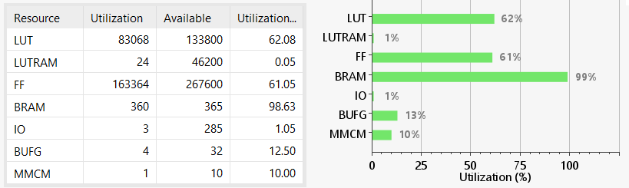
Conclusions:
- The maximum power draw possible on the board was measured at 10.3 W_MTR and 5.63 W_INA. It was achieved with ~61% utilization of all the FF and LUT elements (10000 elements instantiated).
- A higher utilization can be achieved, however the VCCINT power rail draws more power that the regulator can provide, which leads to the shut-off of the regulator, which leads to the FPGA losing configuration.
- The heat is also significant, after a few seconds the FPGA and 1V DC-DC converter are too hot to touch (measured at above 75C). If the FPGA is pushed this hard for a prolonged time without extra thermal management, failure is very likely. The measurements taken may vary by +/- 50mW due to the rapid temperature change.
- The stress test with 10000 elements was tested at 2 separate frequencies: 100MHz and 10MHz, to see how it would affect power consumption. It had a very slight impact that probably comes from measurement errors and rapid heating.
- As the idle power consumption (meaning when the FPGA isn’t toggling all the signals) was also quite high (3.35 W_MTR and 1.9 W_INA) a third variant was tested, where no FF and LUTs were instantiated, to check the static and dynamic power consumption of the BRAM elements. The power consumption was minimal (approx. 0.1 W_INA and 0.2 W_MTR more than a completely empty design).
- On this test, the Vivado power estimator tool seems to consistently measure two times les power draw that the INA and four times less than the MTR!

- Activity: IO tester
- AICORS_demo_simple is a program that initializes all the Input/Output ports that were designed into the board, with their respective characteristics (IOSTANDARD and PACKAGE_PIN), and applies a clock signal of a programmable frequency and duty cycle. It was used to measure the power consumption of the IO buffers used by the FPGA to interact with the ‘exterior’.
- In total there are:
  - 5 LVDS pairs (negative and positive), powered at 2.5V, using the OBUFDS buffer.
  - 12 LVTTL pairs, powered at 3.3V.
    - The I2C lines use the OBUFT tristate buffer.
    - All the others use the default output buffer set by Vivado.
- Four frequencies were tested, all with a 50% duty-cycle: 10, 50, 100 and 250MHz
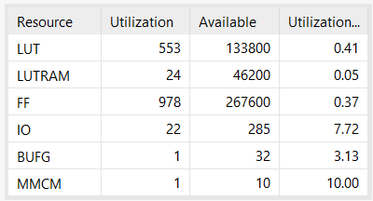
Conclusions:
- As expected, power consumption was increased only on the 3.3V and 2.5V rails. However, no change was detected on the 2.5V rail when a different frequency was applied (idk why).
- Regarding the 3.3V rail, it increased linearly up to 100MHz (0.77 – 0.98 W_INA and 1.89 – 2.16 W_MTR), after which it decreased slightly at 250MHz. My guess is that the electrical circuit couldn’t keep pace with this high frequency, so the signal didn’t have a chance to achieve its full waveform, thus decreasing the power consumed.
- The Vivado power estimation tool doesn’t seem to take into consideration the frequency of the design, it giving the same result on all the tested frequencies. It seems to be in line with the INA measurement of the 10MHz variant (0.730W total power draw).

- Activity: Detector unit
- Now we tested the Detector_unit_V5.3 project, which is the actual project meant for this board.
- It uses all the available BRAMs to store known bit patterns, after which it scans all the available addresses to check for bit-flips. If a bit-flip is found, it generates a SEU event that is stored in a FIFO structure to be further processed by the AI model.
- Two frequencies were tested: 50MHz and 10MHz.
- The program is configured in such a way that, when a full memory scan is finished, another one begins. There is NO wait period between the scans.
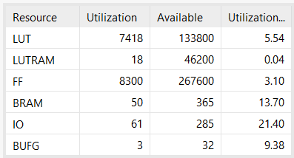
Conclusions:
- As expected, power consumption was higher on the 50MHz version; what was peculiar though, was the difference of consumption between the two versions. The 10MHz version consumes 43%_INA - 58%_MTR less power when active and 58%_INA - 75%_MTR when idle (project is not scanning the memories).
- The only changed in power consumption was detected on the 1V rail, the other rails having the exact same power draw, regardless of frequency, or the active/idle status of the module.
- The Vivado power estimation tool doesn’t seem to take into consideration the frequency of the design, it giving the same result on all the tested frequencies. It seems to be in line with the INA measurement of the 50MHz variant (1.25W total power draw).
- The heating of the FPGA and power regulators is not a problem, them being only slightly warm to the touch when active.
- General power estimations:
- To account for the 0.48W_INA and 1.5W_MTR static power consumption of the PCB, a general analysis of all the active components present on the board was performed.
- The results are presented in the table below: each component found to consume power, its voltage rating, the current and power draw value found in each components datasheet, and the quantity present on the board
Conclusions:
- The total calculated power draw is 1.06W, which comes relatively close to the 1.5W measured by the power meter. The other 0.5W could be coming from the FPGA, which was not included in this analysis and from datasheet inaccuracies, measurement errors or other factors.

